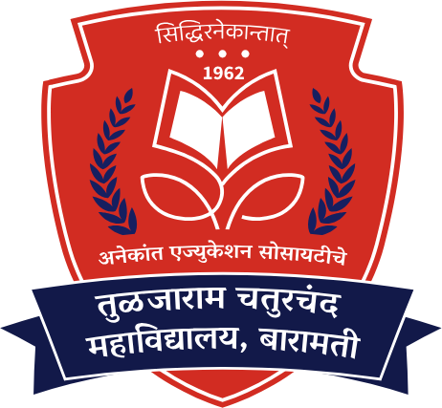

Anekant Education Society’s

Tuljaram Chaturchand College of Arts, Science & Commerce - [TCC],

(Autonomous) Baramati

Affiliated to Savitribai Phule Pune University, Pune

Field Project

Subject: - Solar Company Admin Webpage

Client / Owner: - Vishal Mane
Roll No | Name
12402 | Kunal Prakash Jadhav.
12436 | Abhishek Yashwant Saste.

DIV: - ‘A’

SEMESTER: - V

Academic Year: - 2024-25.

Guide Name: - Ms. Snehal Takawane.



Anekant Education Society’s

Tuljaram Chaturchand College

of Arts, Science & Commerce, Baramati-413102

(EMPOWERED AUTONOMOUS)

Affiliated to

Savitribai Phule Pune University, Pune

DEPARTMENT OF COMPUTER SCIENCE

- CERTIFICATE-

Date: / /

This is to certify that Mr./Miss. /Smt.

has satisfactorily completed the course in the practical as prescribed by Tuljaram Chaturchand College of Arts, Science & Commerce, Baramati (Autonomous), affiliated to SPPU for the T. Y. B. Sc. (Computer Science), COS-355-FP (Field Project) (As Per NEP 2024 Pattern) in the Year 2025- 2026

Project  Guide | Internal  Examiner | External  Examiner | HOD  Computer Science

